Task:
Install Docker on EC2 and explore the Docker commands (docker images, containers, volumes, network)
Step-1: EC2_Creation on AWS:
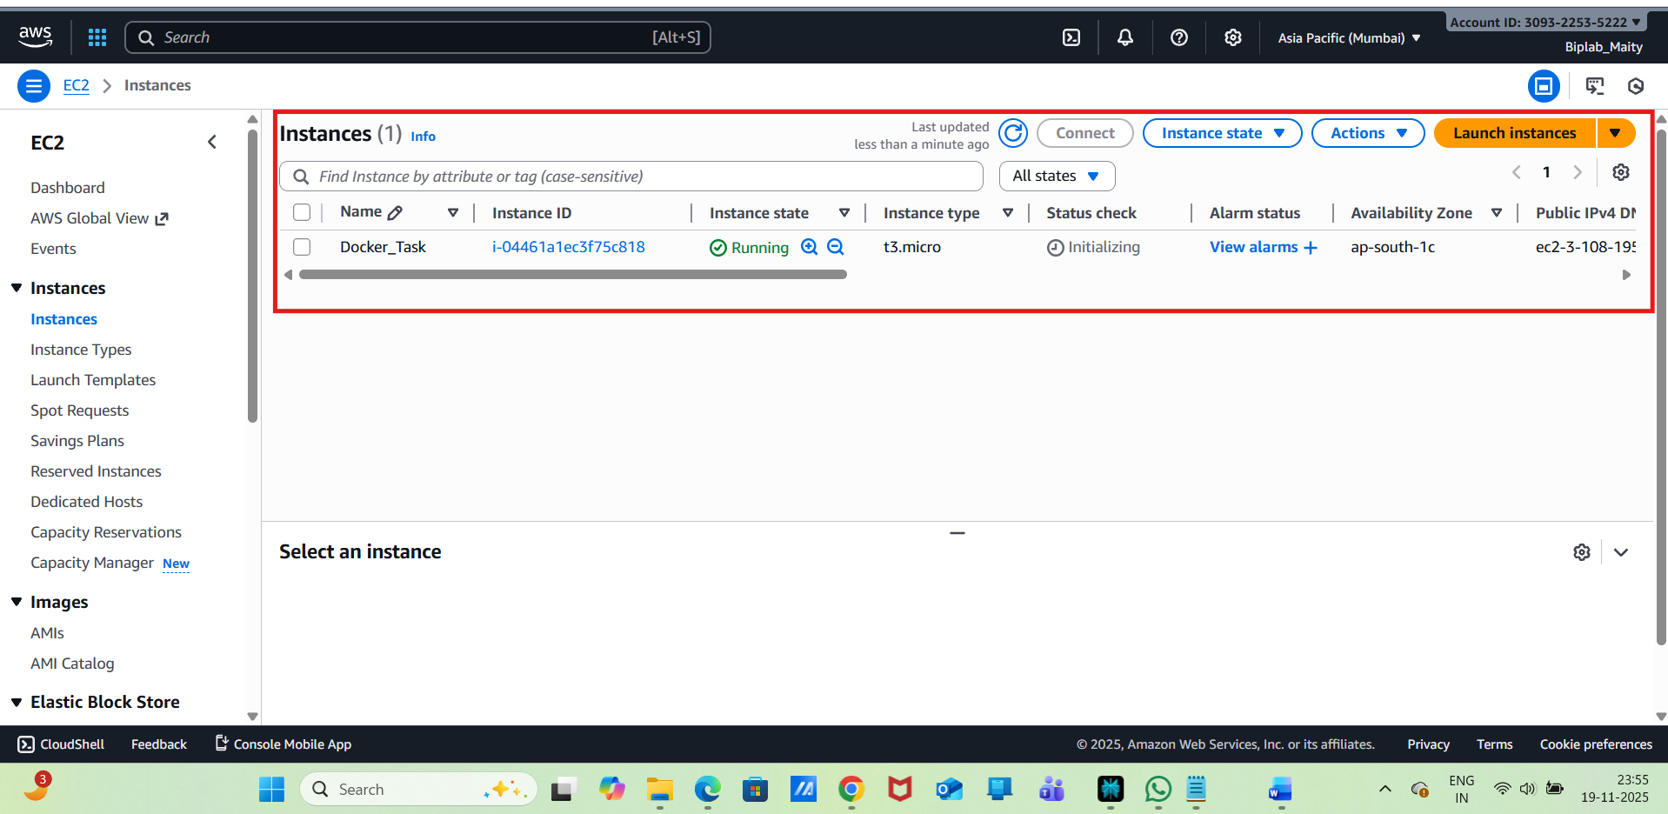
Connect with public IP :
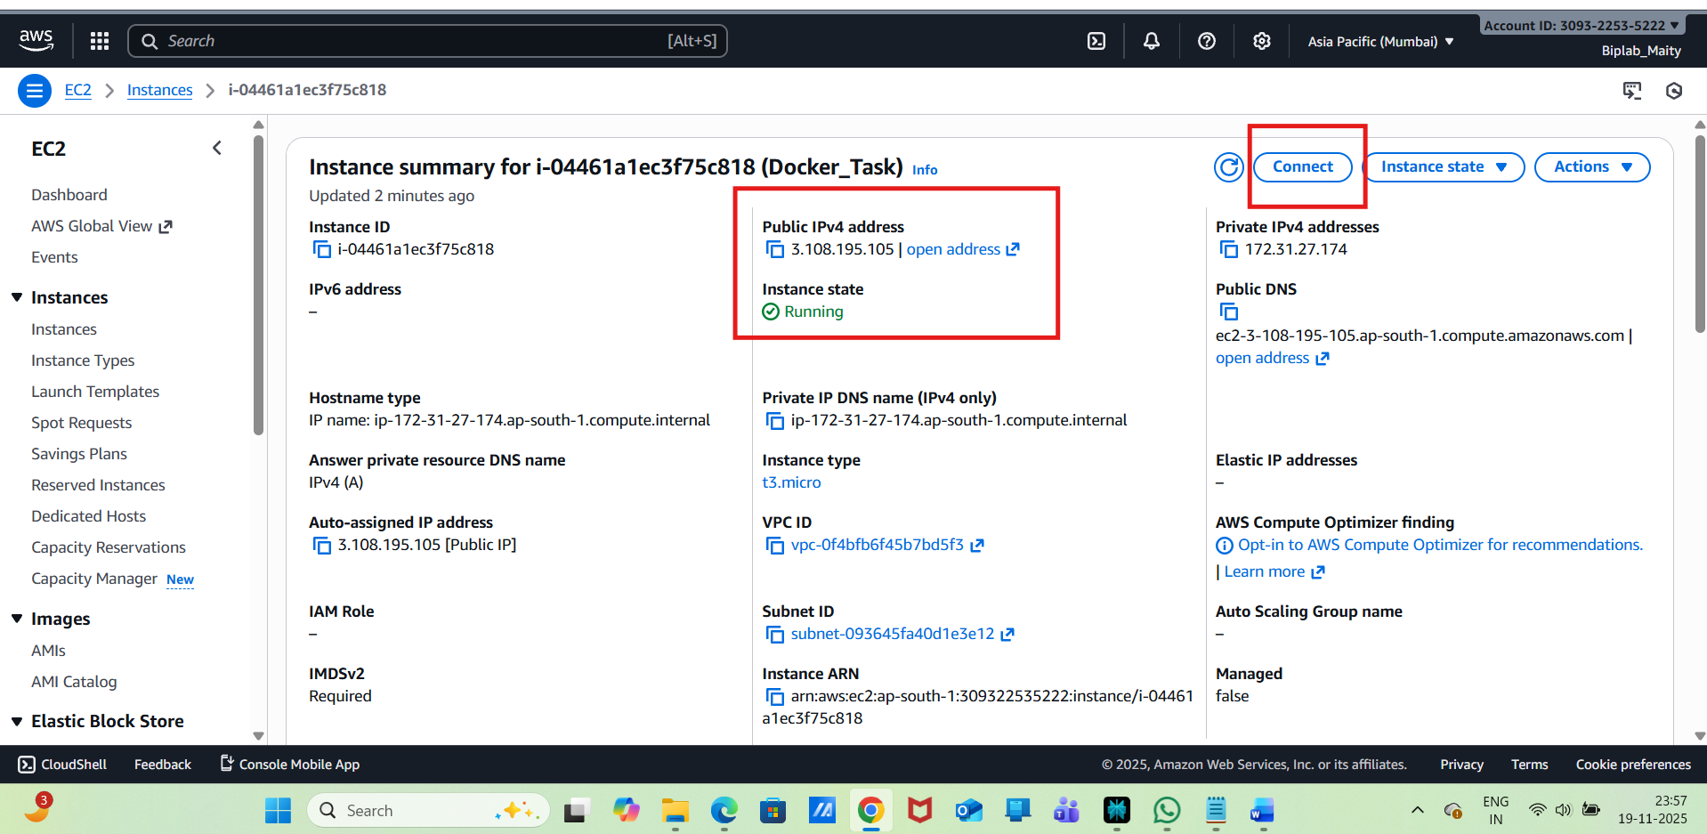
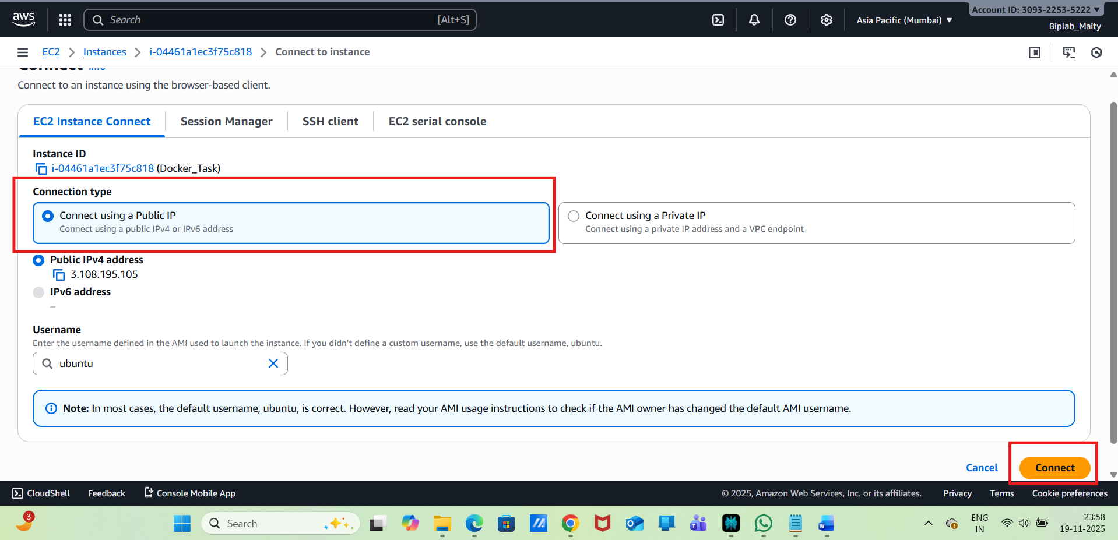
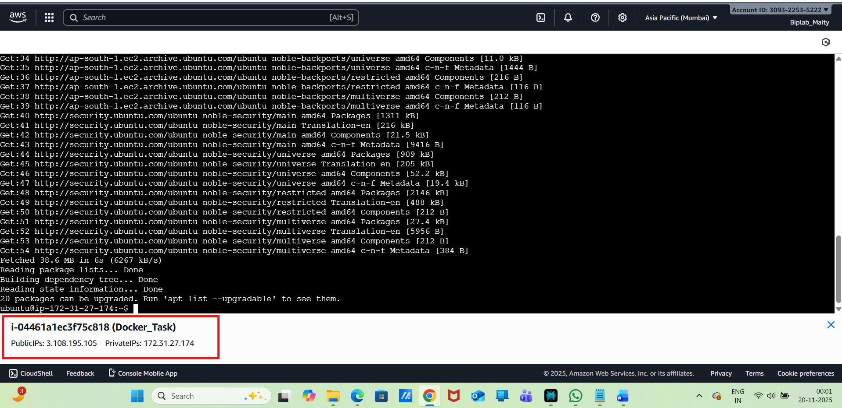
Step:-2: Install Docker on EC2:
Install Docker Engine on Ubuntu:
sudo apt update -y
sudo apt install ca-certificates curl gnupg
Add Docker's official GPG key:

sudo install -m 0755 -d /etc/apt/keyrings
curl -fsSL https://download.docker.com/linux/ubuntu/gpg | sudo gpg --dearmor -o /etc/apt/keyrings/docker.gpg
sudo chmod a+r /etc/apt/keyrings/docker.gpg
Add the Docker repository to APT sources:

echo \
"deb [arch="$(dpkg --print-architecture)" signed-by=/etc/apt/keyrings/docker.gpg] https://download.docker.com/linux/ubuntu \
"$(. /etc/os-release && echo "$VERSION_CODENAME")" stable" | \
sudo tee /etc/apt/sources.list.d/docker.list > /dev/null
Install Docker Engine, CLI, containerd, and Docker Compose plugin:
sudo apt-get install docker-ce docker-ce-cli containerd.io docker-buildx-plugin docker-compose-plugin
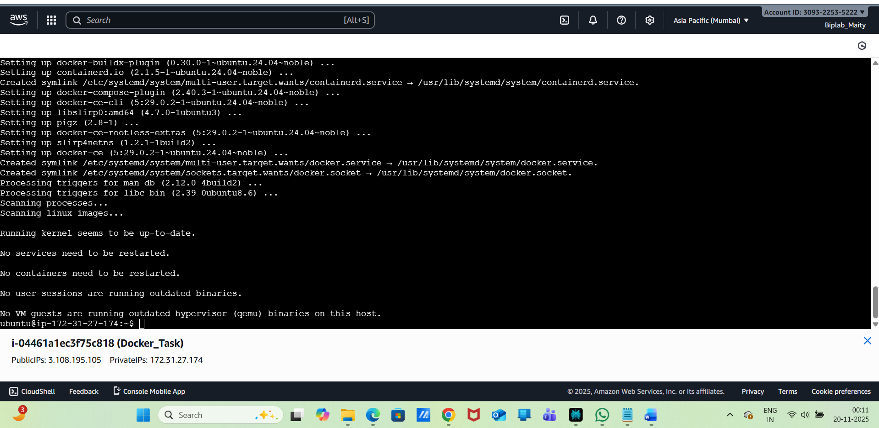
Verify the installation :
sudo docker run hello-world
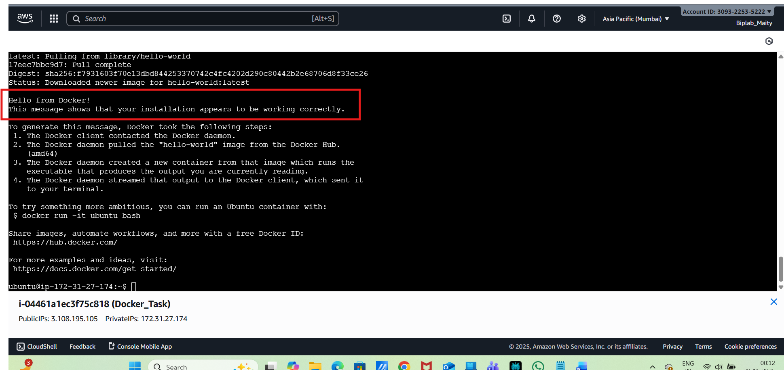
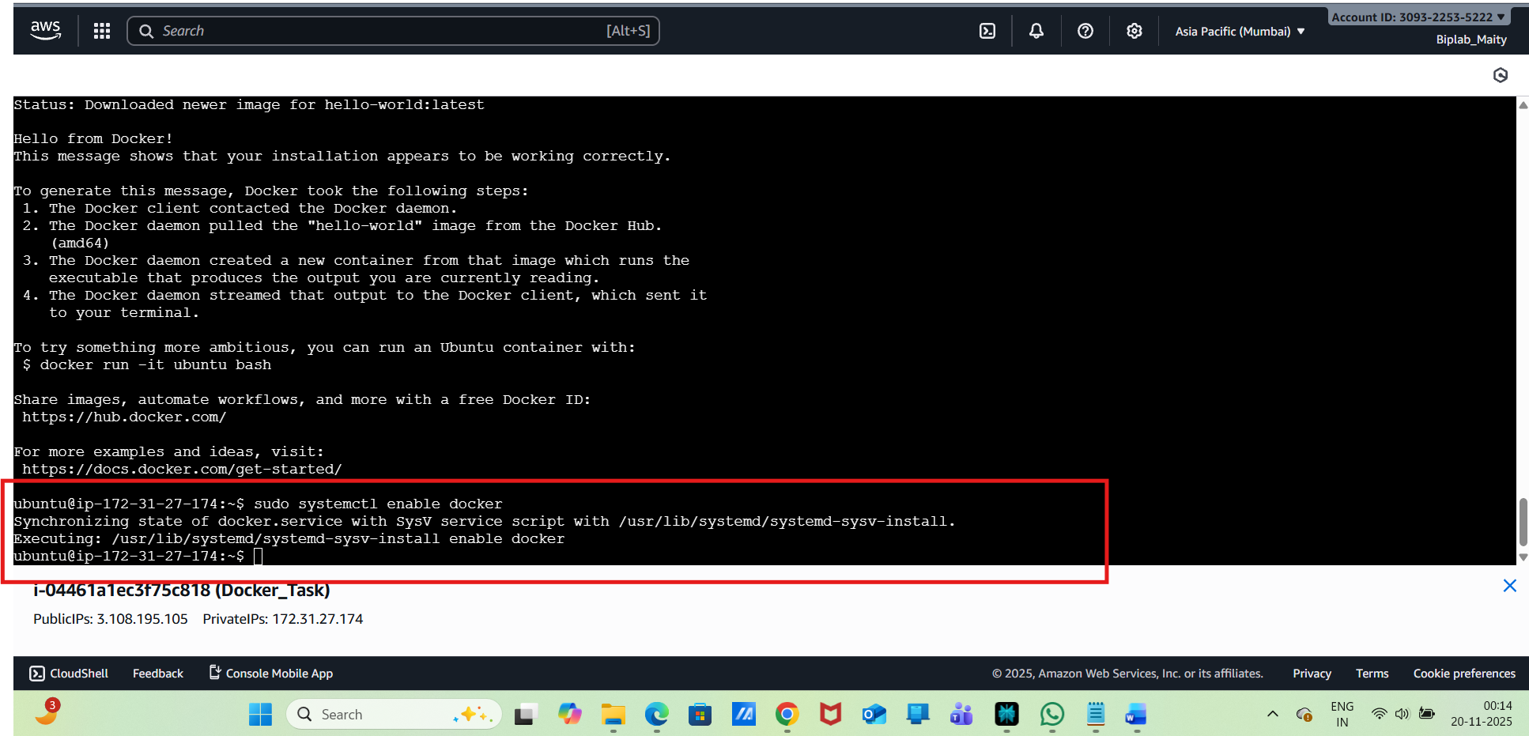
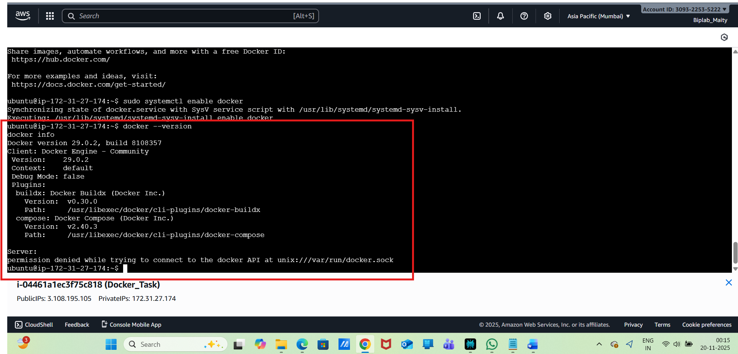
Docker Images:
To run Docker commands without sudo, add your user to the docker group:
sudo usermod -aG docker $USER
logout and login back to EC2:
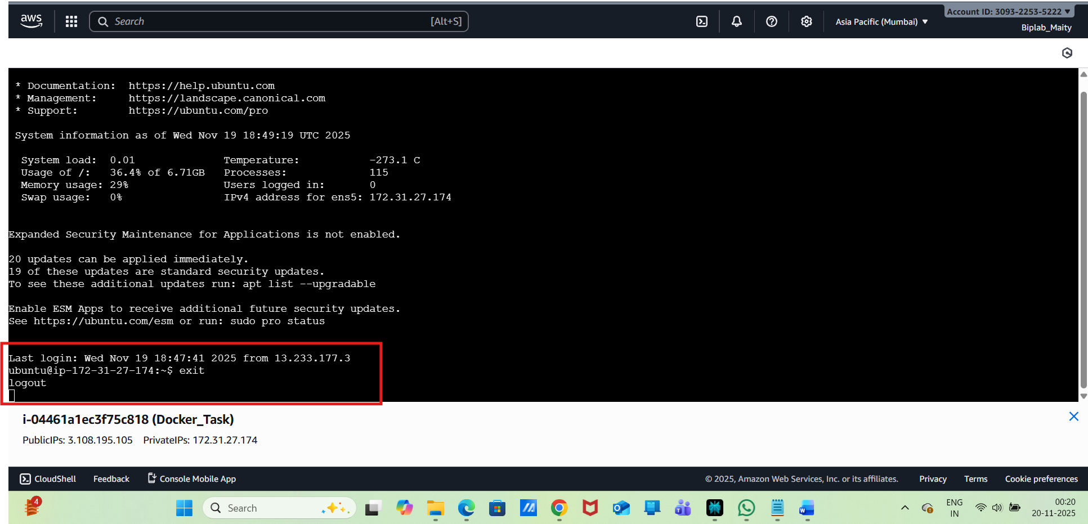
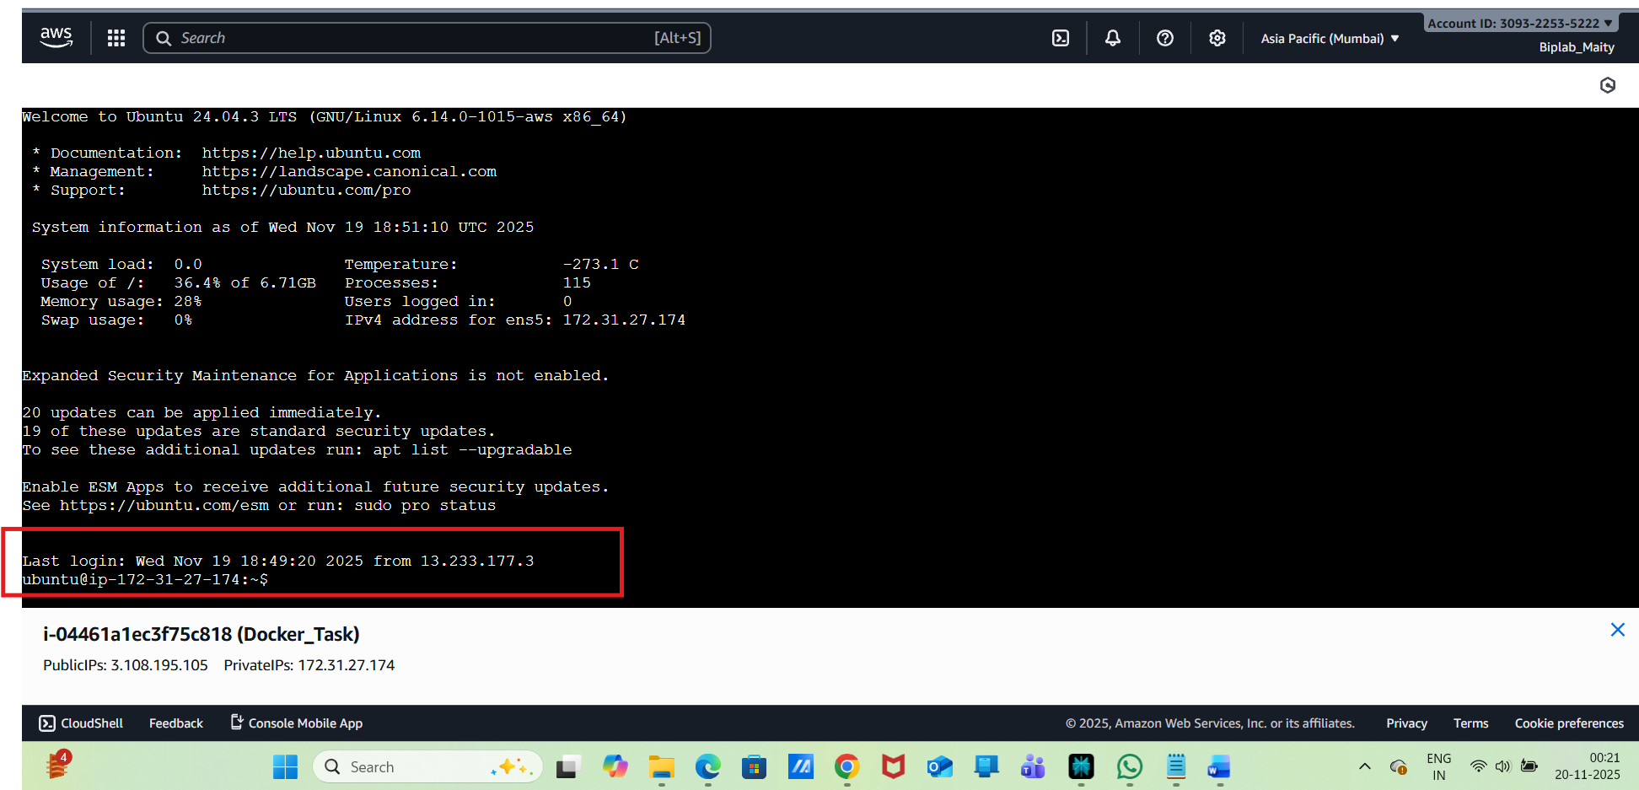
Now check :
List images:
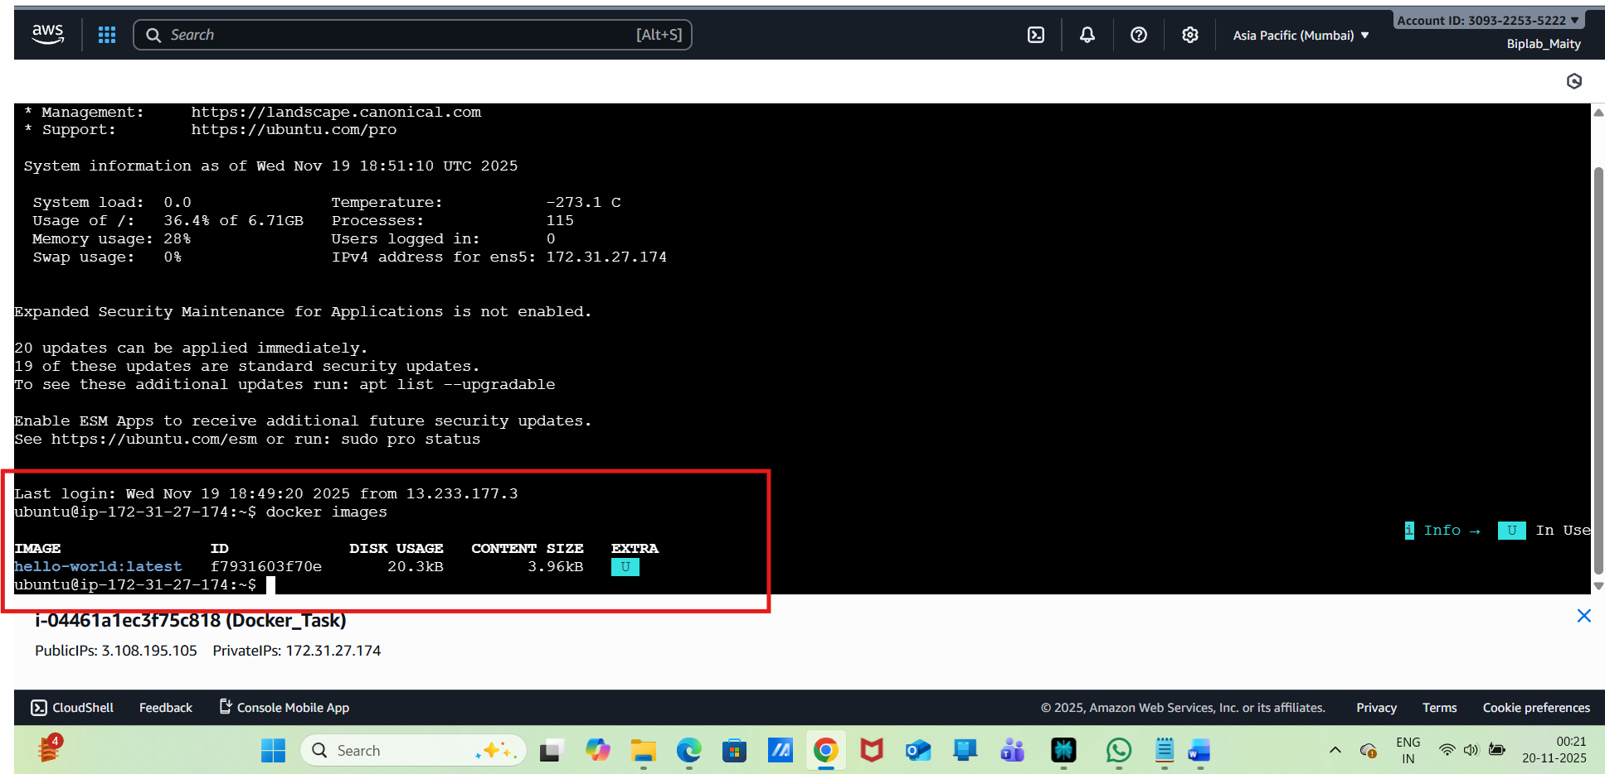
Pull an image:
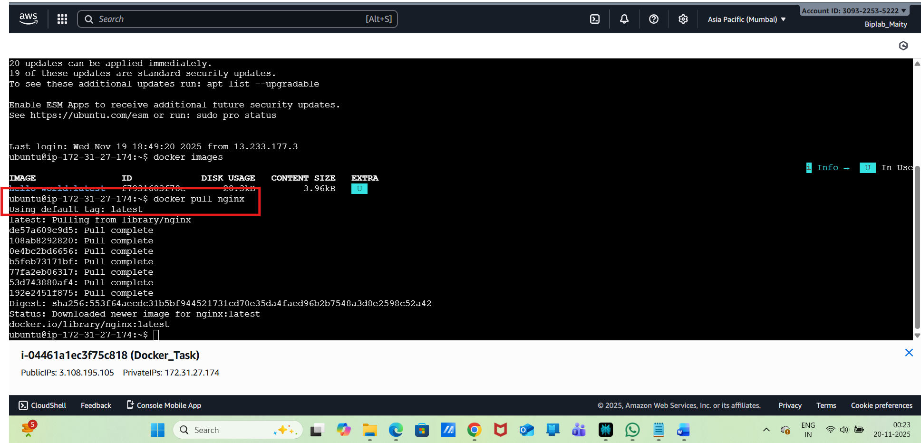
Remove an image:
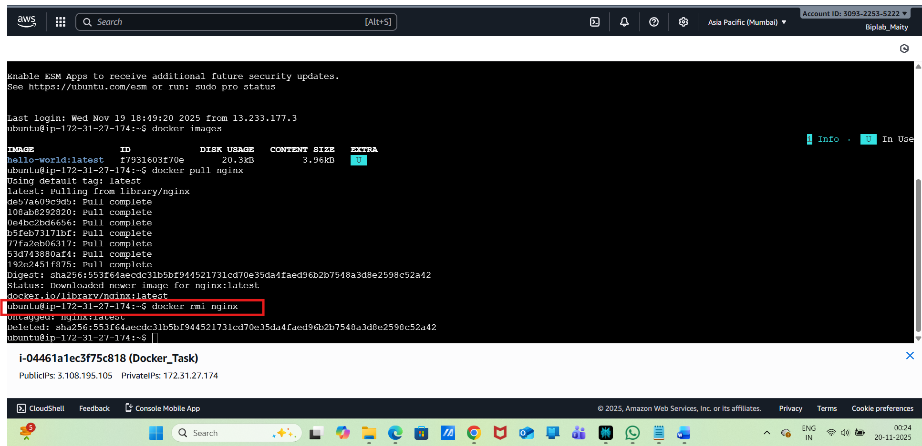
Step 3: Docker Containers:
Run a container:
docker run -d --name my-nginx -p 80:80 nginx
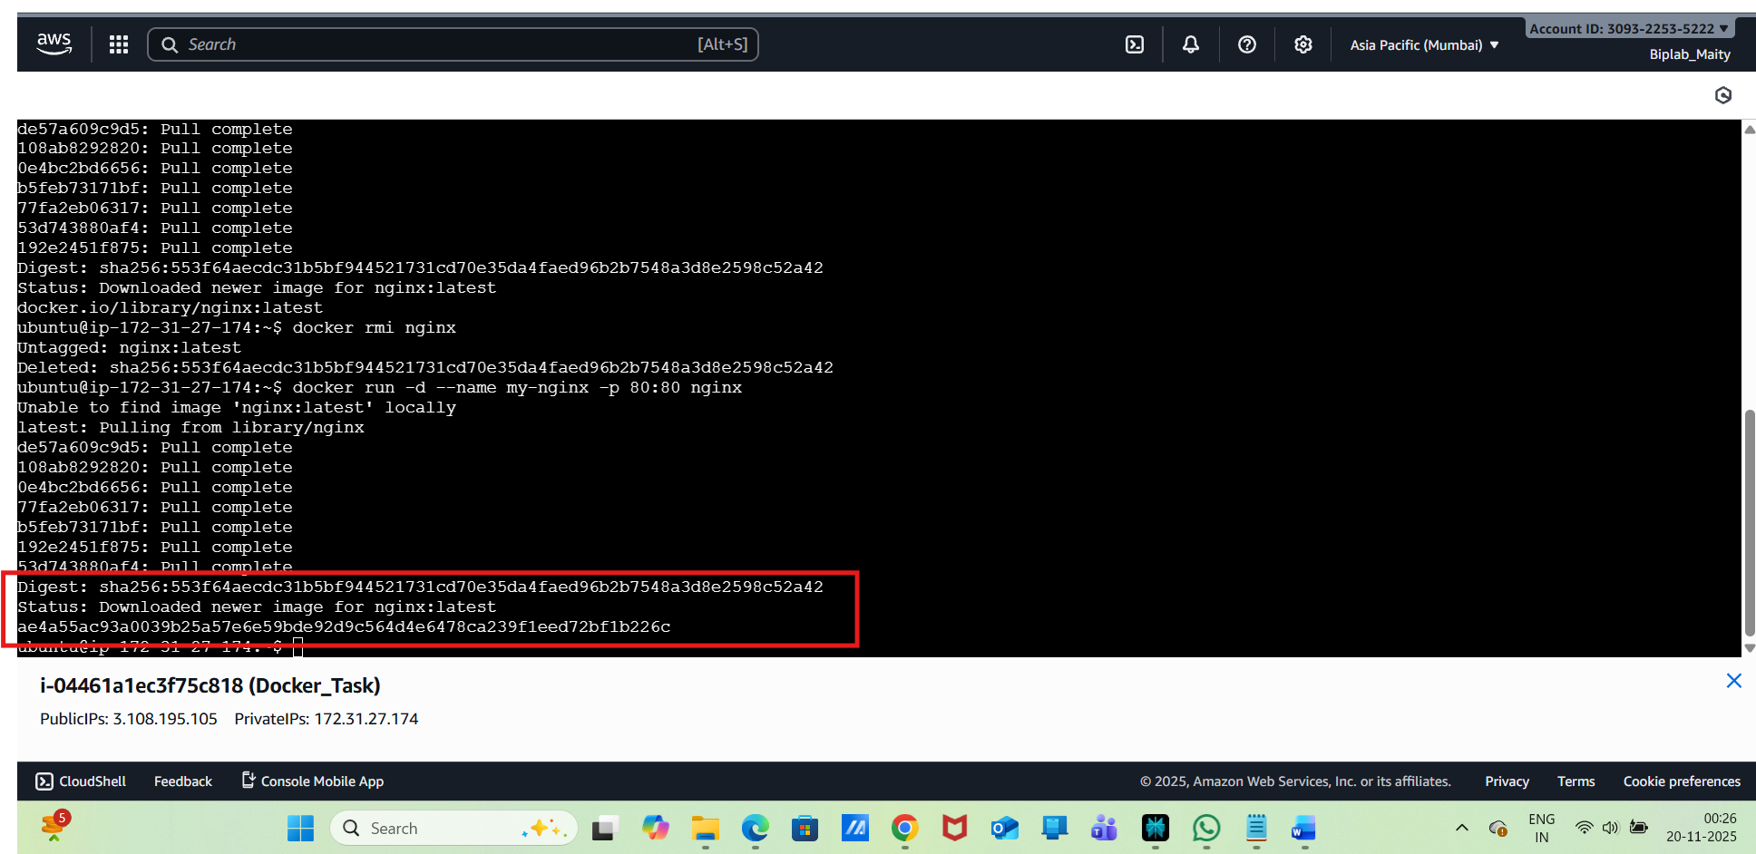
List running containers:
docker ps

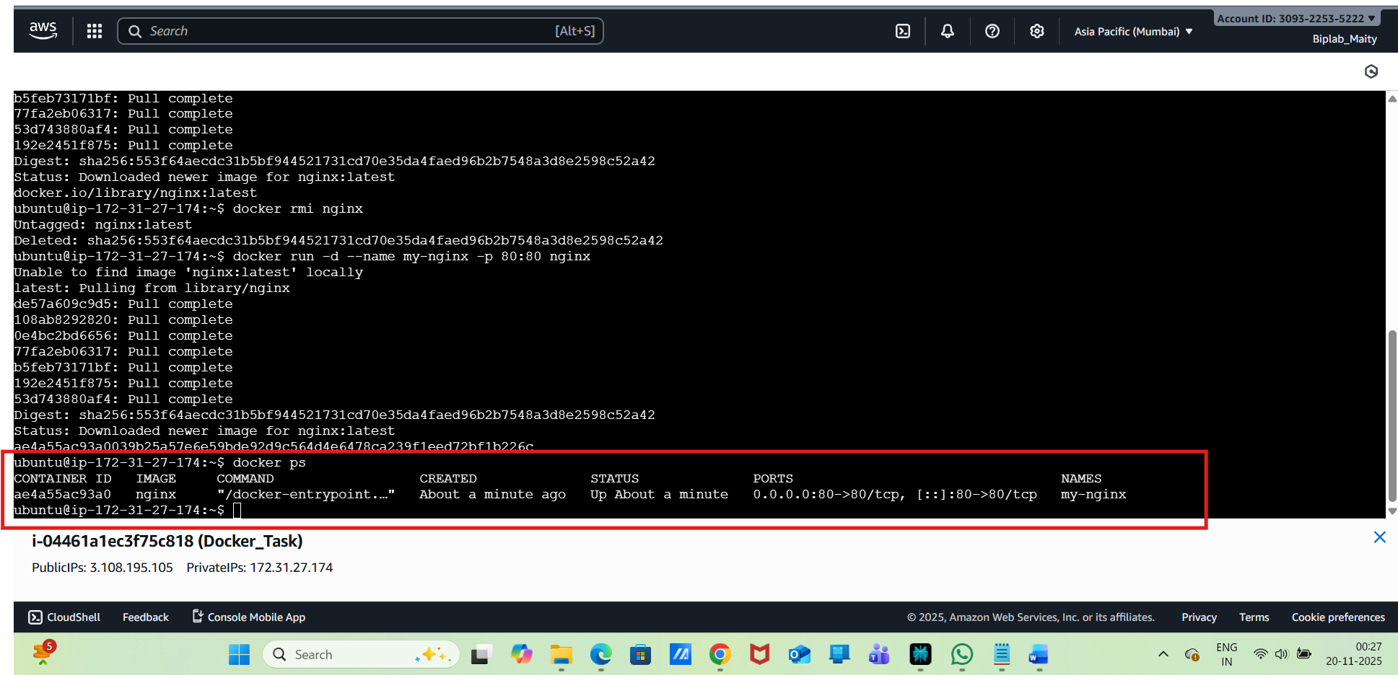
List all containers:
docker ps -a
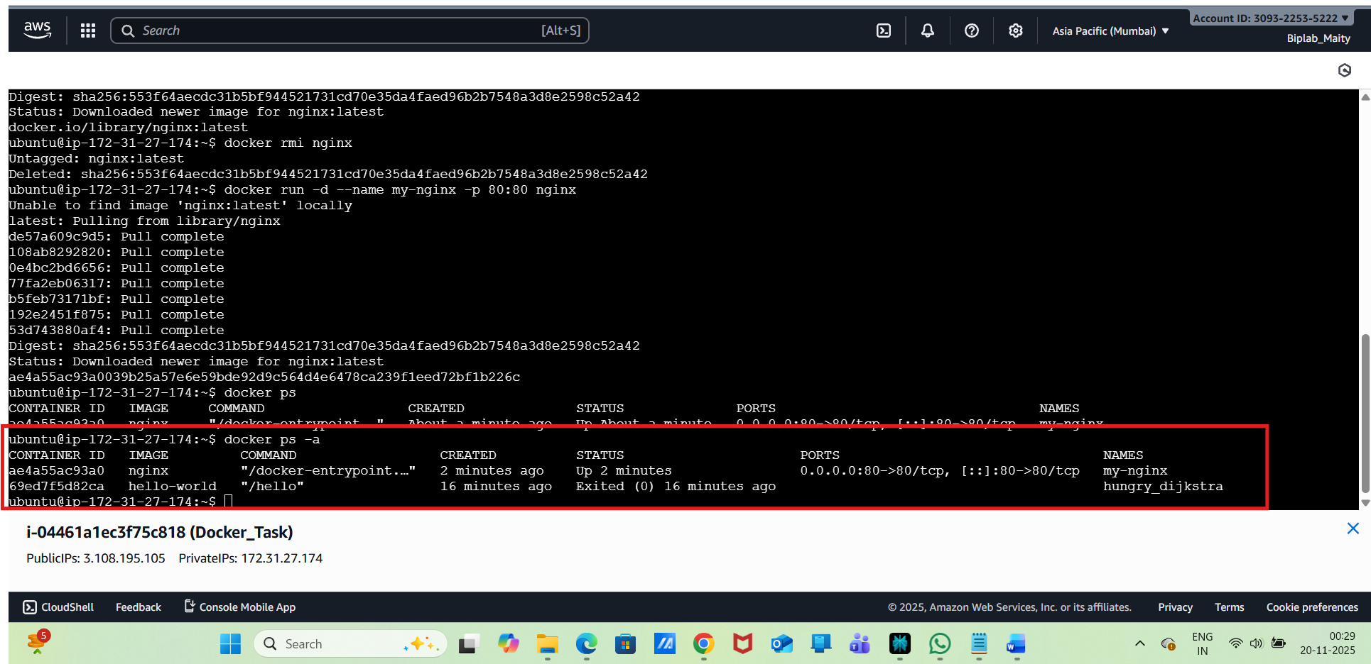
Stop a container:
docker stop my-nginx
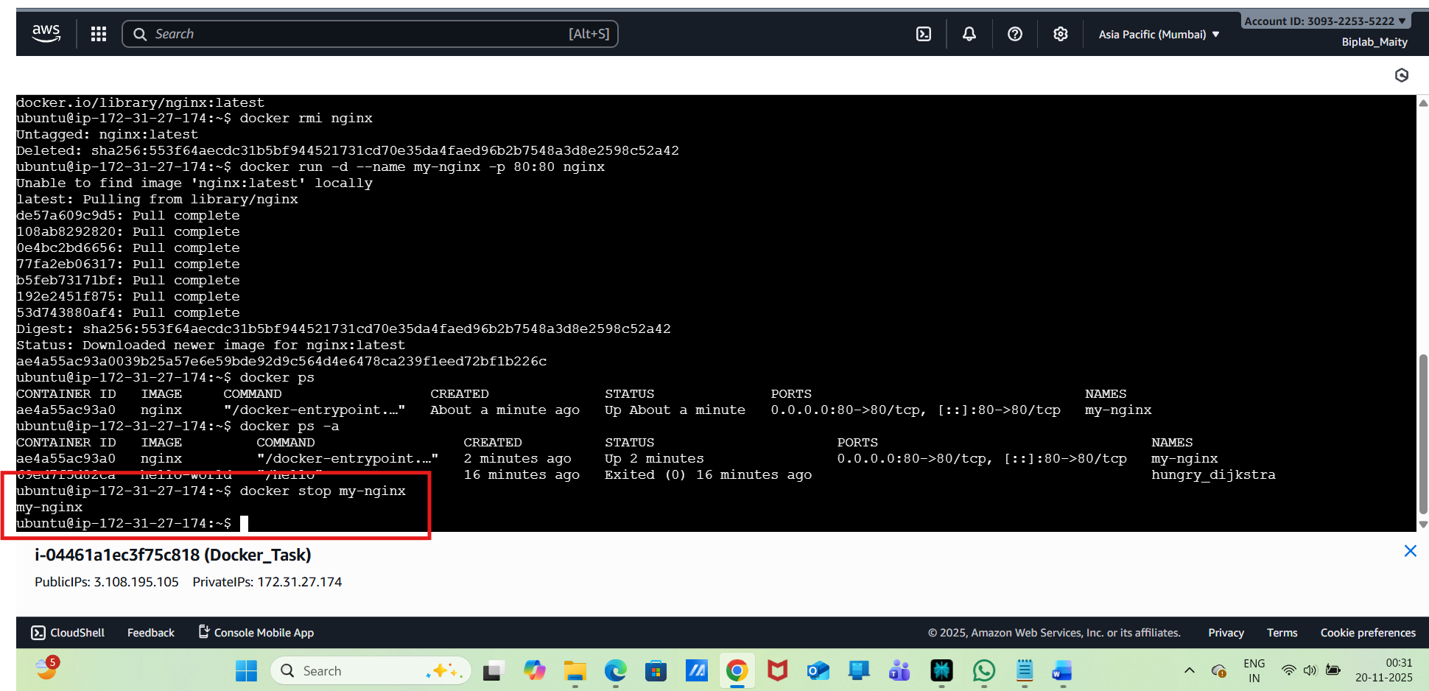
Start a container:
docker start my-nginx
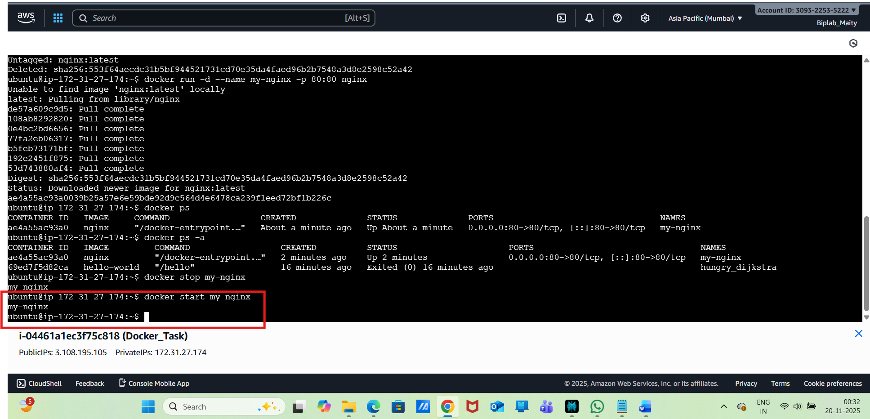
Docker Volumes:
Create a volume:
docker volume create mydata
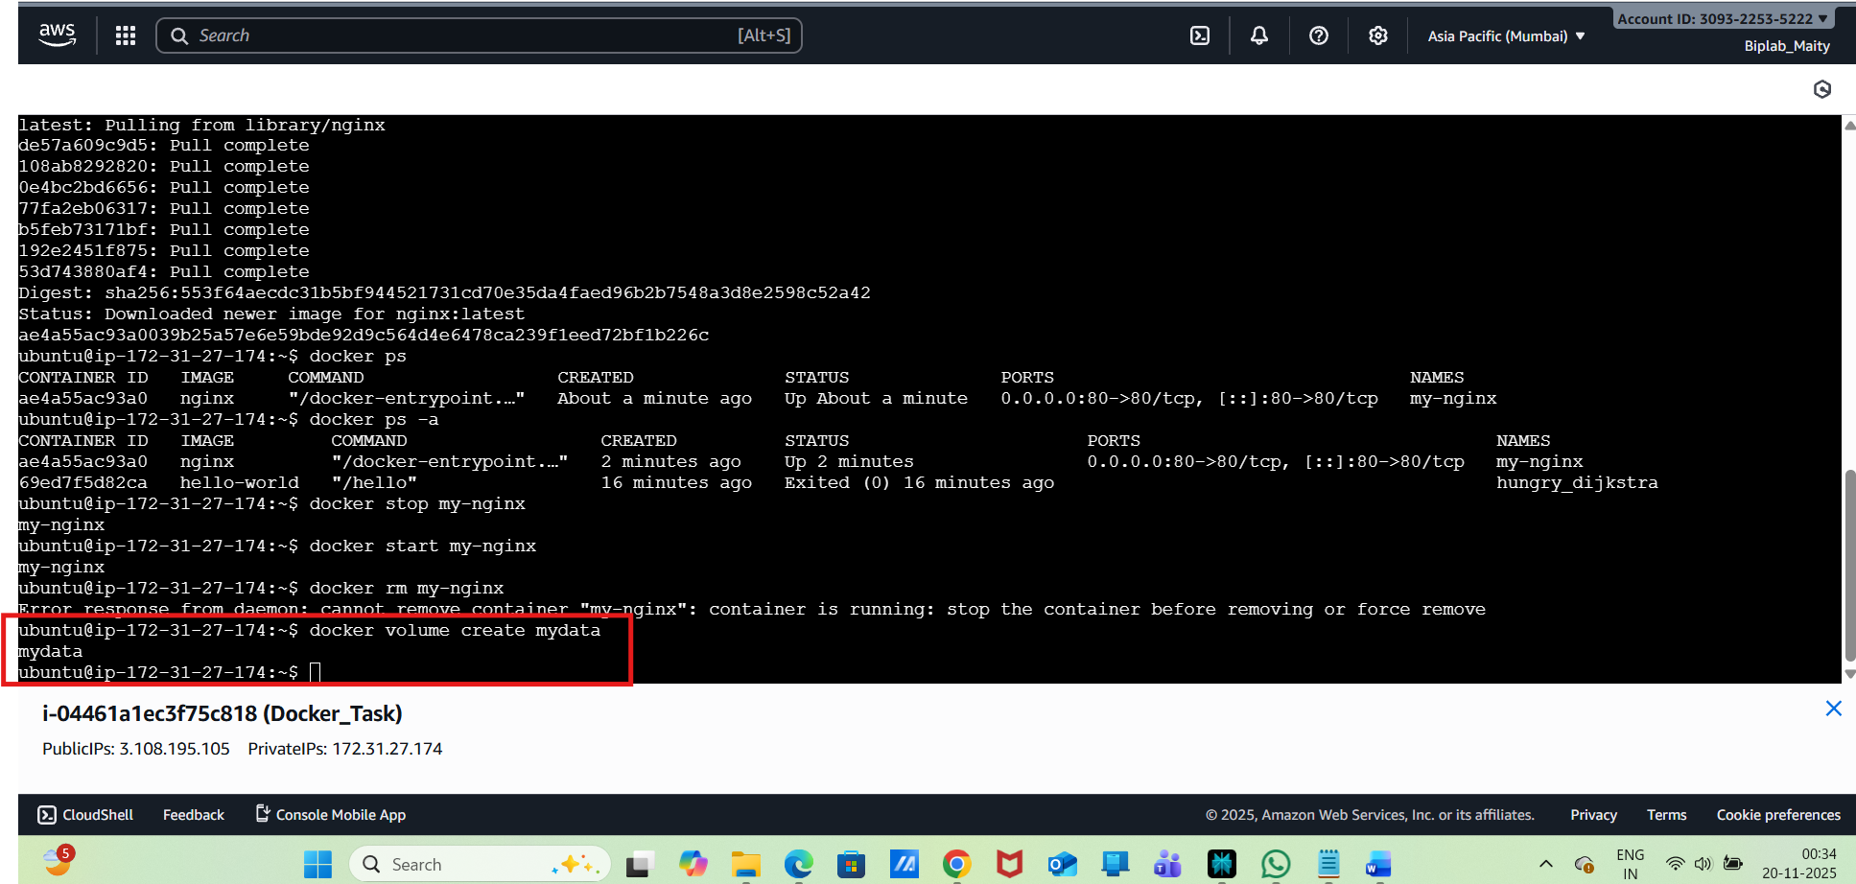
List volumes:
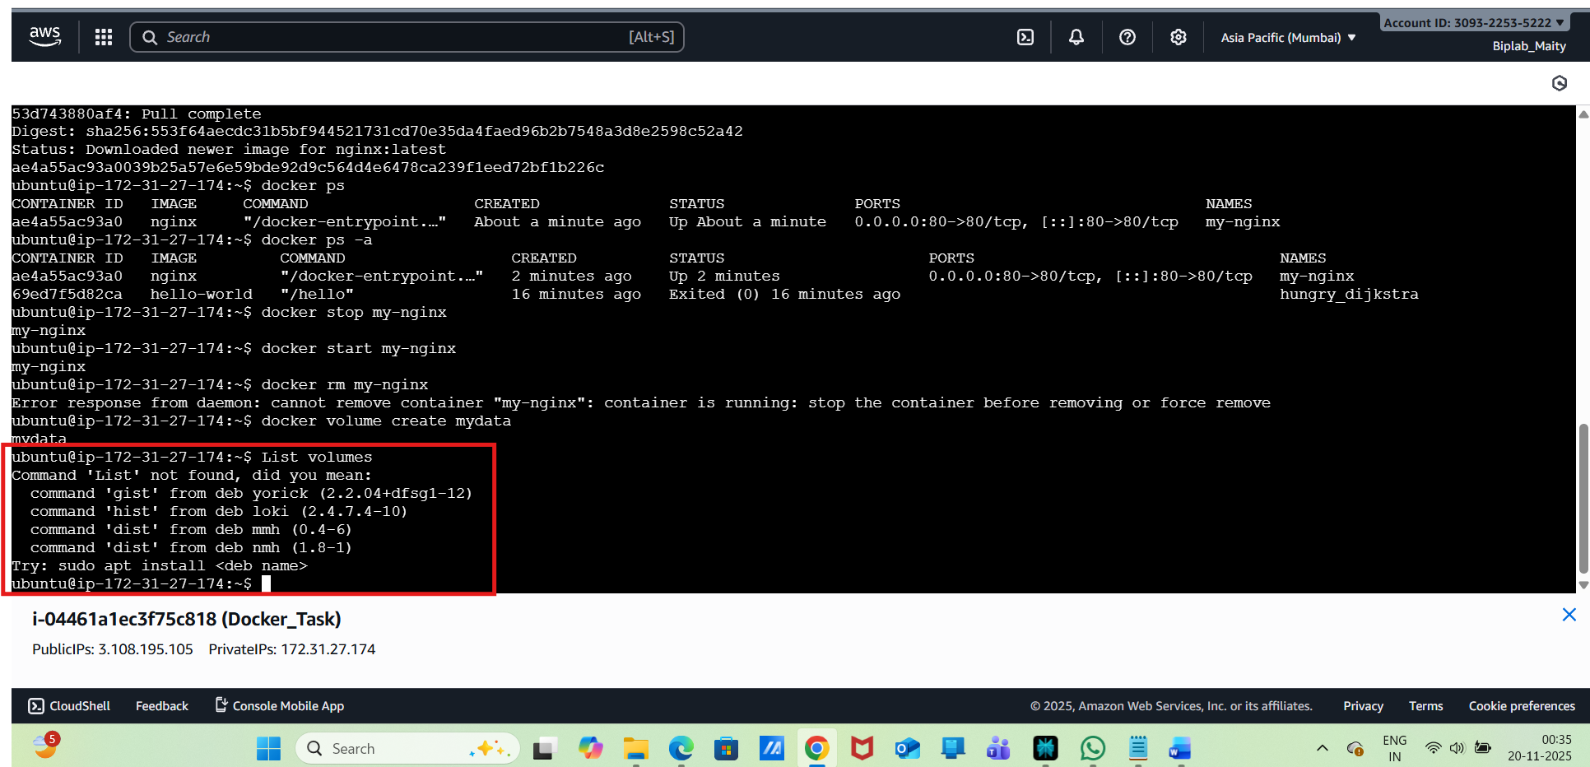
Inspect a volume:
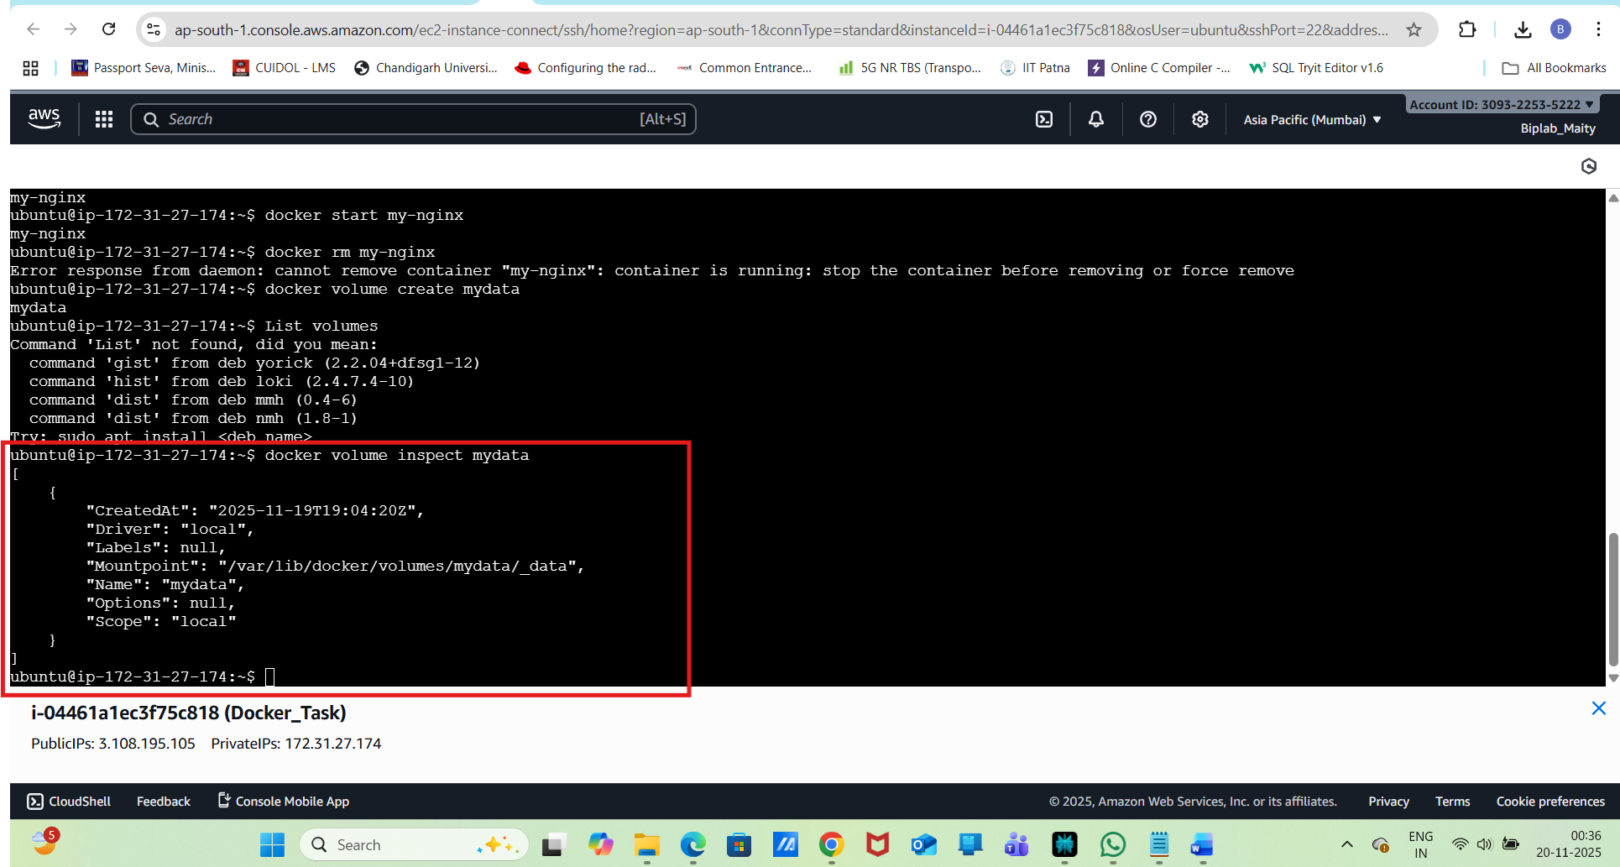
Use a volume with a container:
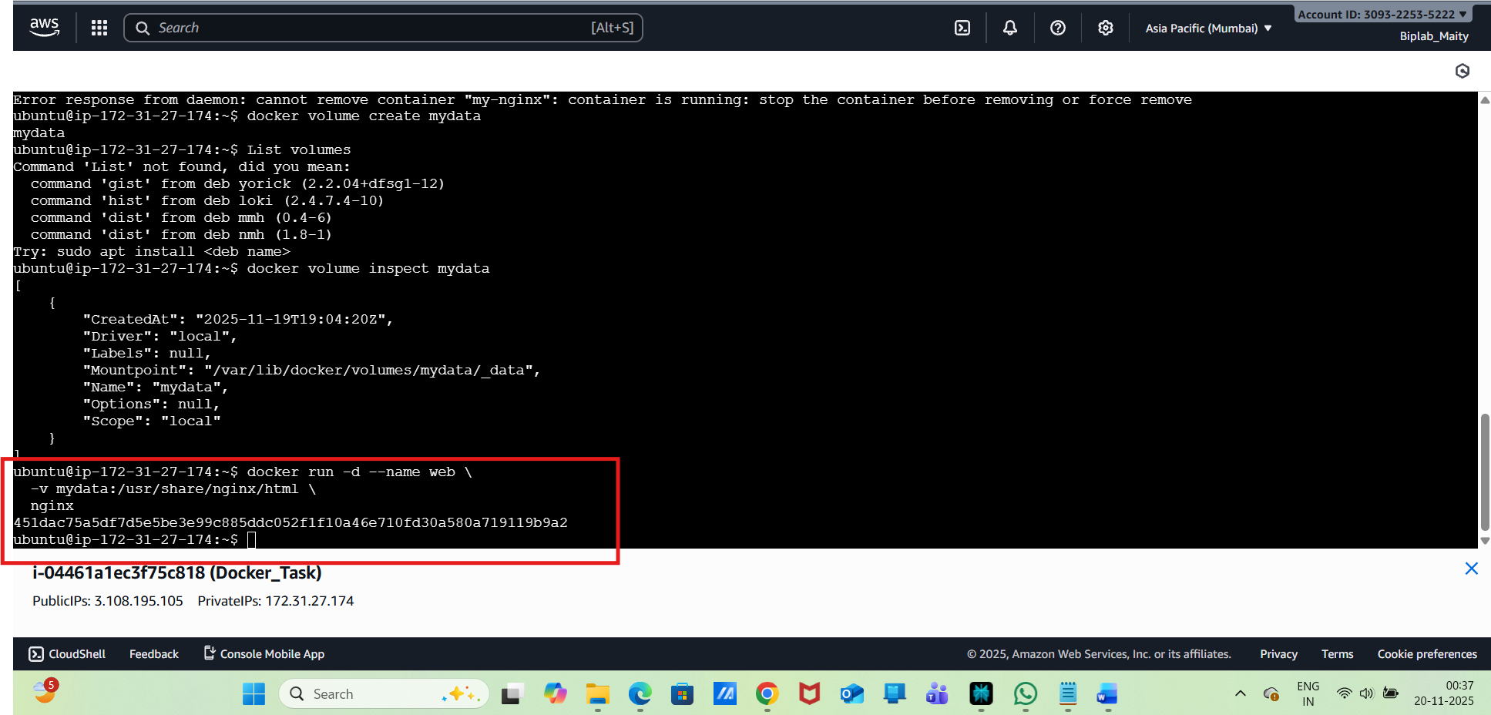
Remove a volume:
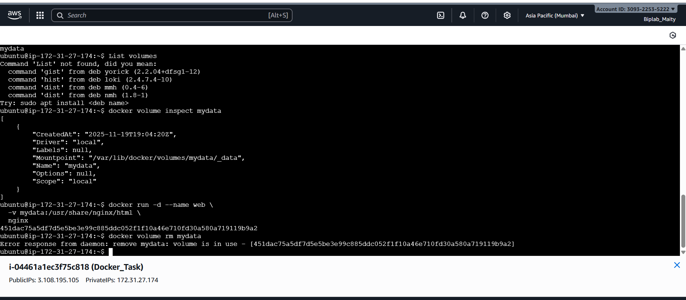
Step 4: Docker Networks:
List networks:
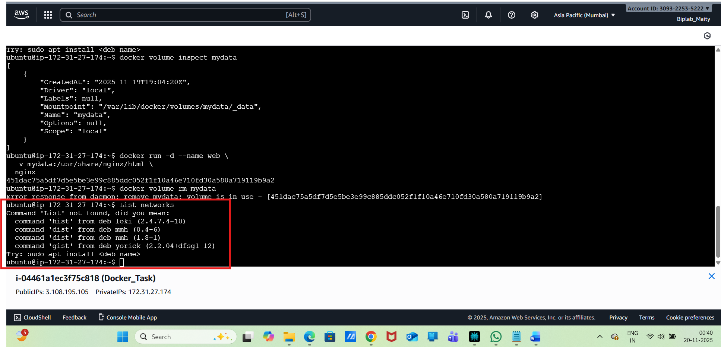
Create a network:
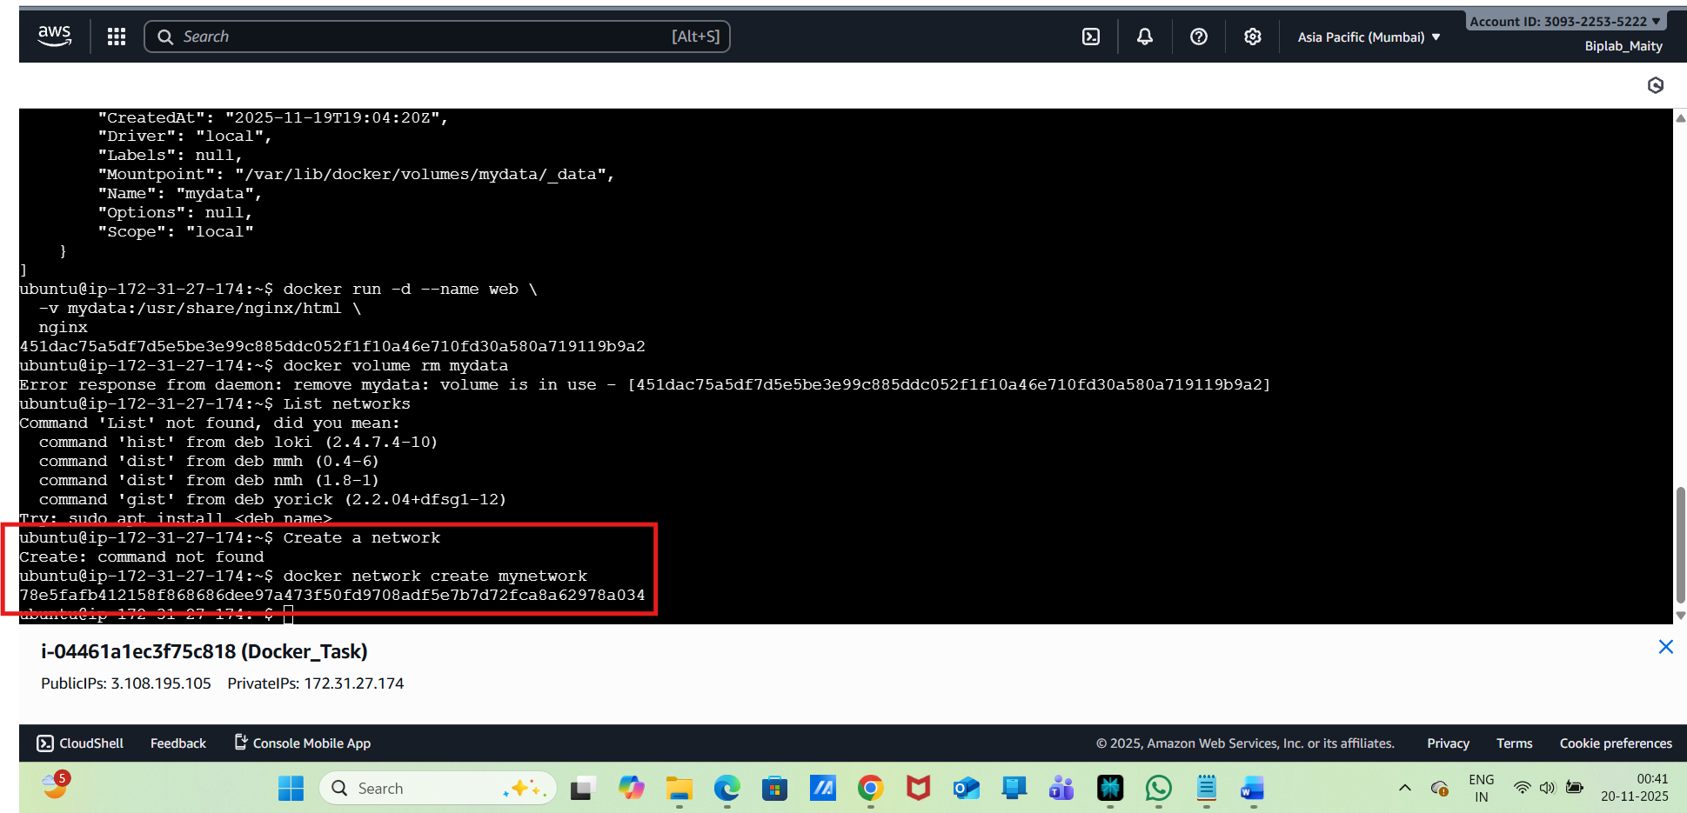
Inspect network:
78e5fafb412158f868686dee97a473f50fd9708adf5e7b7d72fca8a62978a034
ubuntu@ip-172-31-27-174:~$ docker network inspect mynetwork
[
{
"Name": "mynetwork",
"Id": "78e5fafb412158f868686dee97a473f50fd9708adf5e7b7d72fca8a62978a034",
"Created": "2025-11-19T19:11:37.745677923Z",
"Scope": "local",
"Driver": "bridge",
"EnableIPv4": true,
"EnableIPv6": false,
"IPAM": {
"Driver": "default",
"Options": {},
"Config": [
{
"Subnet": "172.18.0.0/16",
"IPRange": "",
"Gateway": "172.18.0.1"
}
]
},
"Internal": false,
"Attachable": false,
"Ingress": false,
"ConfigFrom": {
"Network": ""
},
"ConfigOnly": false,
"Options": {},
"Labels": {},
"Containers": {},
"Status": {
"IPAM": {
"Subnets": {
"172.18.0.0/16": {
"IPsInUse": 3,
"DynamicIPsAvailable": 65533
}
}
}
}
}
]
ubuntu@ip-172-31-27-174:~$
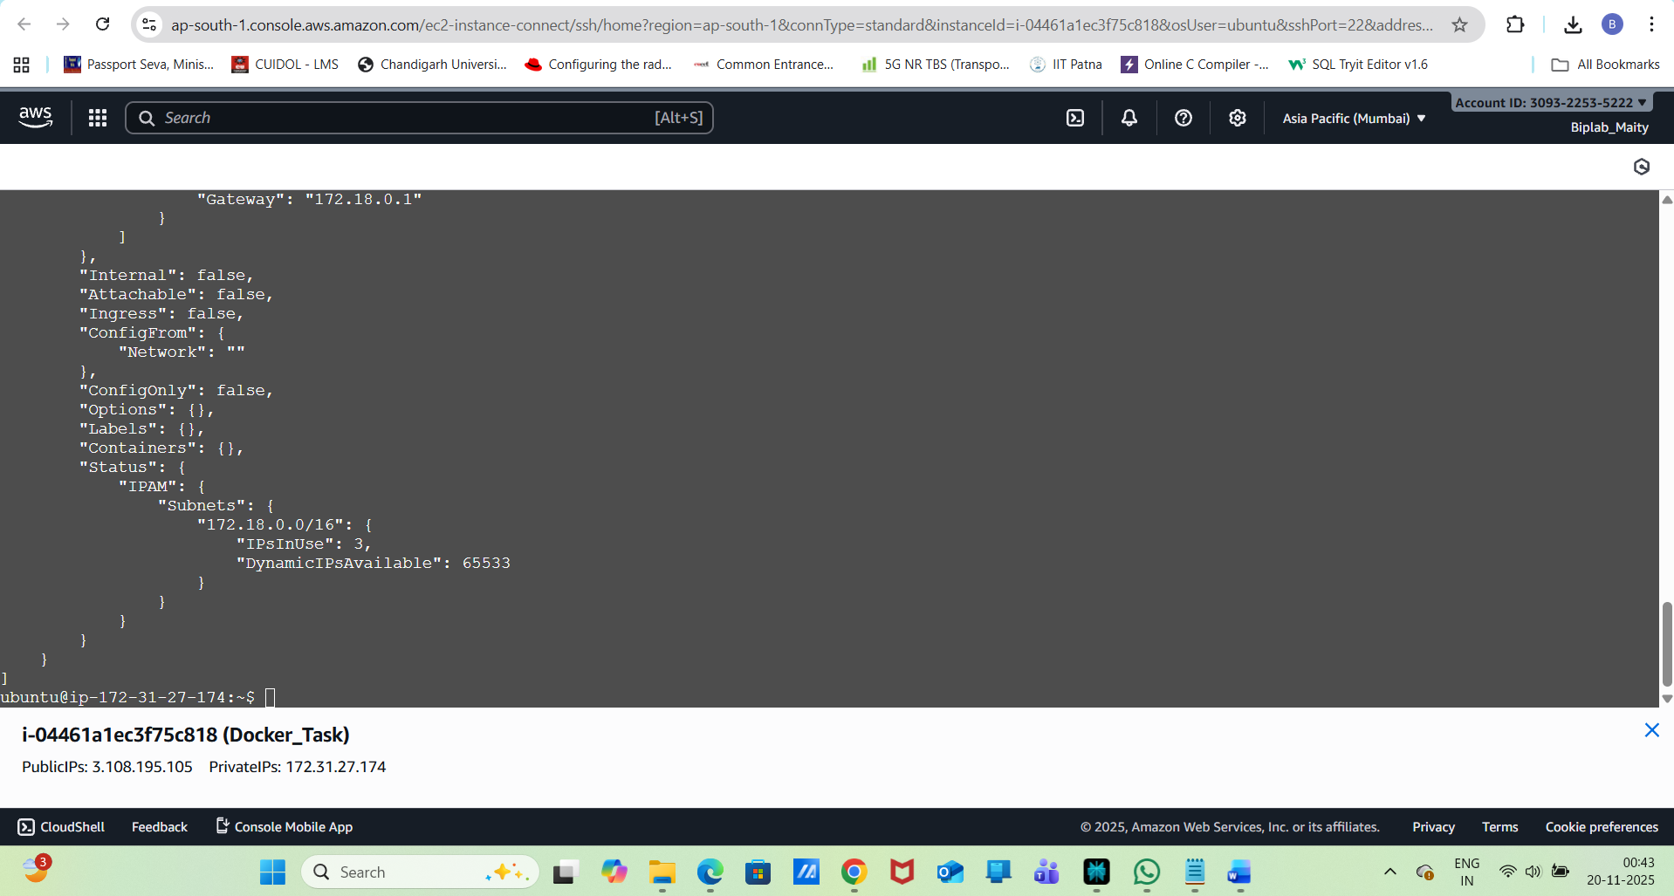
Run a container in a custom network:
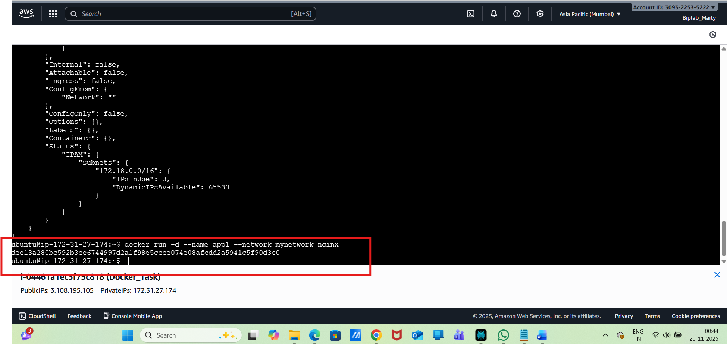
Remove a network:
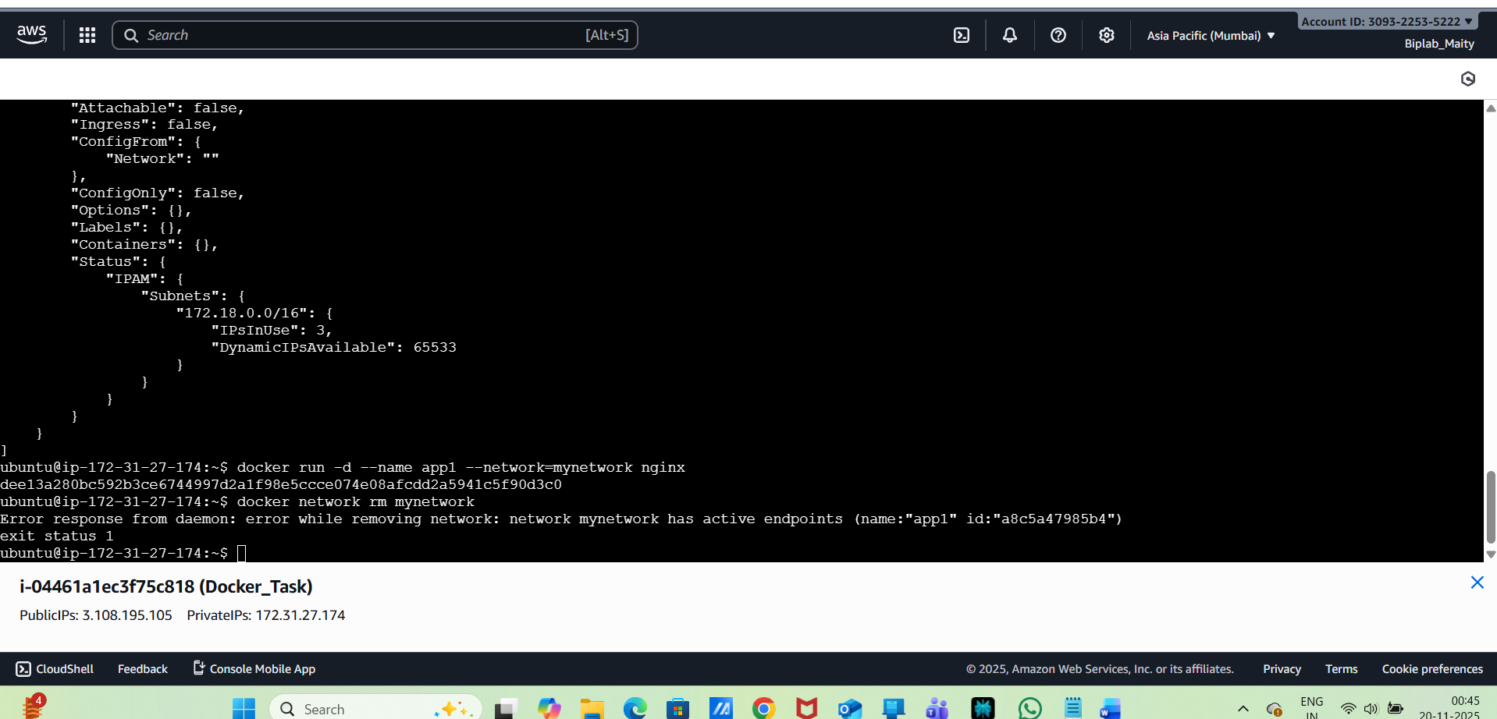
Cleanup Commands:
Remove all stopped containers:
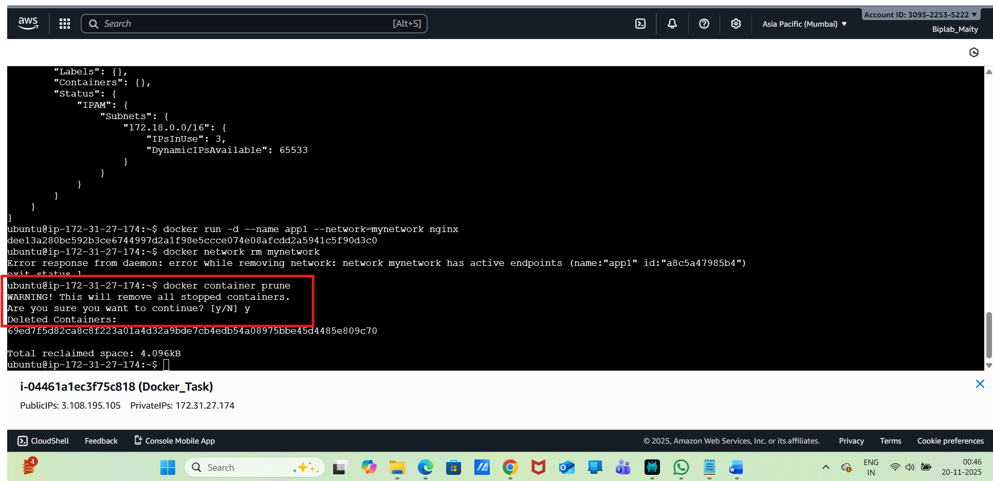
Remove unused images:
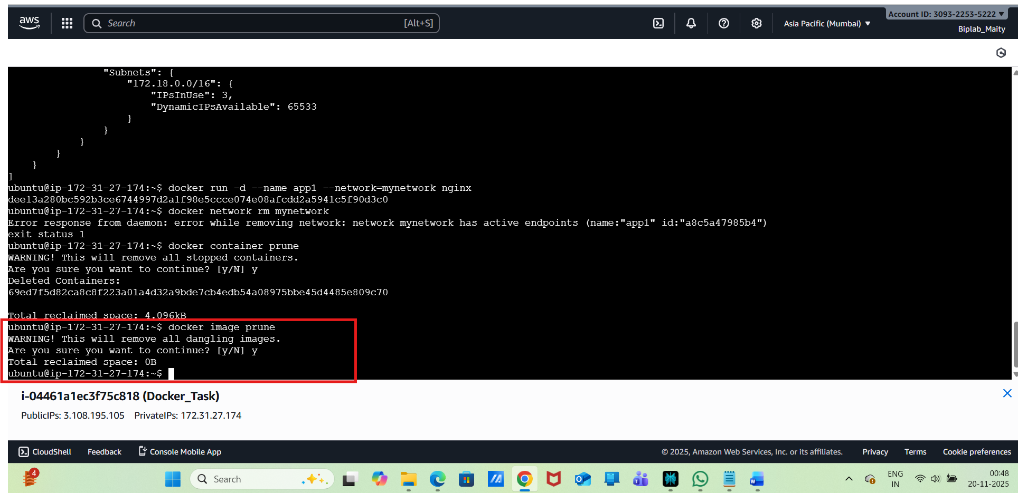
Remove unused volumes:
